EXPT NO: 7 | IMPLEMENTATION OF A SIMPLE AUTOENCODER FOR DIMENSIONALITY REDUCTION AND FEATURE LEARNING
DATE: 01/11/2026

PRE-LAB QUESTIONS (PROVIDE BRIEF ANSWERS TO THE FOLLOWING QUESTIONS)
Midhun P 24BAD069

- Discuss the roles of the Encoder and Decoder in an Autoencoder.

Autoencoder is an unsupervised neural network used to learn efficient representations of data.
It consists of three main components: Encoder, Bottleneck, and Decoder.
The Encoder takes the input data and compresses it into a lower-dimensional representation by extracting important features.
For example, a 28 × 28 MNIST image with 784 pixel values can be reduced to only 32 values.
The Bottleneck is the central layer that stores this compressed information.
It forces the network to retain only the most meaningful patterns instead of memorizing the entire input.
The Decoder reconstructs the original data from the compressed representation and restores it to the original dimensions.
The network compares the reconstructed output with the original input and updates its weights to minimize reconstruction error.
Thus, an autoencoder learns compact feature representations while preserving important information in the data.

- Explain how an Autoencoder performs dimensionality reduction.

Dimensionality reduction reduces the number of features while preserving important information.
An Autoencoder performs this using its Encoder, Bottleneck, and Decoder.
The Encoder extracts key features from the input and compresses them into a smaller representation.
For example, an MNIST image with 784 pixel values can be reduced to 32 latent features.
The Bottleneck stores this compact representation of the data.
The Decoder reconstructs the original input from the compressed features.
During training, the reconstructed output is compared with the original input to minimize reconstruction error.
Reducing 784 dimensions to 32 dimensions gives a reduction of about 95.92%.
Thus, Autoencoders achieve dimensionality reduction while retaining the most important information in the data.

- Why is a bottleneck layer important in an Autoencoder architecture?

Bottleneck Layer is the central layer of an Autoencoder that stores a compressed representation of input data.
It is important because it restricts the amount of information passed from the Encoder to the Decoder.
The bottleneck contains fewer neurons than the input layer, helping reduce dimensionality.
For example, a 784-dimensional image can be compressed into a 32-dimensional latent vector.
This forces the network to learn meaningful features instead of simply copying the input.
Compression can remove some redundant or less useful information from the data.
The compact representation can be used for tasks like visualization, clustering, and machine learning.
The size of the bottleneck affects reconstruction quality, as a very small bottleneck may lose important information.
Thus, the bottleneck layer plays a key role in learning efficient and compact data representations.

AIM
To implement and train a simple Autoencoder for dimensionality reduction and feature learning by compressing input data into a lower-dimensional representation and reconstructing the original data from the learned features.

SOFTWARE REQUIREMENTS
- Python
- TensorFlow / Keras / PyTorch
- Google Colab
- GitHub
- NumPy
- Matplotlib
- Pandas
- Scikit-learn

OBJECTIVES
Students will be able to:
- Understand the architecture and working of an Autoencoder.
- Identify the functions of the Encoder, bottleneck, and Decoder.
- Prepare and normalize input data for Autoencoder training.
- Build and train an Autoencoder using a suitable dataset.
- Perform dimensionality reduction through latent-space representations.
- Evaluate reconstruction performance using suitable loss metrics.
- Visualize reconstructed data and analyze the learned features.
- Document the experiment and manage the notebook using GitHub.

PROCEDURE
PART A: DATASET PREPARATION
Perform the following tasks:
- Load a suitable dataset, such as the MNIST handwritten digits dataset.
- Explore the dataset and examine sample input images.
- Identify the dimensions and data types of the input samples.
- Normalize the pixel values to a suitable range, such as 0 to 1.
- Reshape the input images into one-dimensional vectors if using a Dense Autoencoder.
- Split the dataset into training and testing datasets.
- Use the input data as both the input and target output for reconstruction.
- Display a sample of the original images.

(CODE: CONATAINS STUDENT ROLL NOS
SCREENSHOT OF CODE
SCREENSHOT OF OUTPUT)
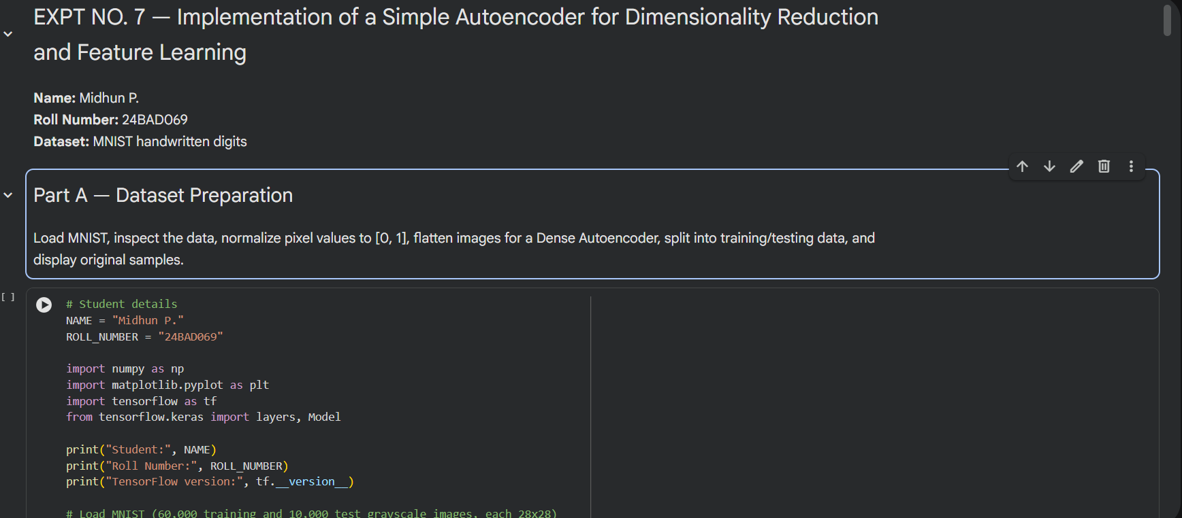
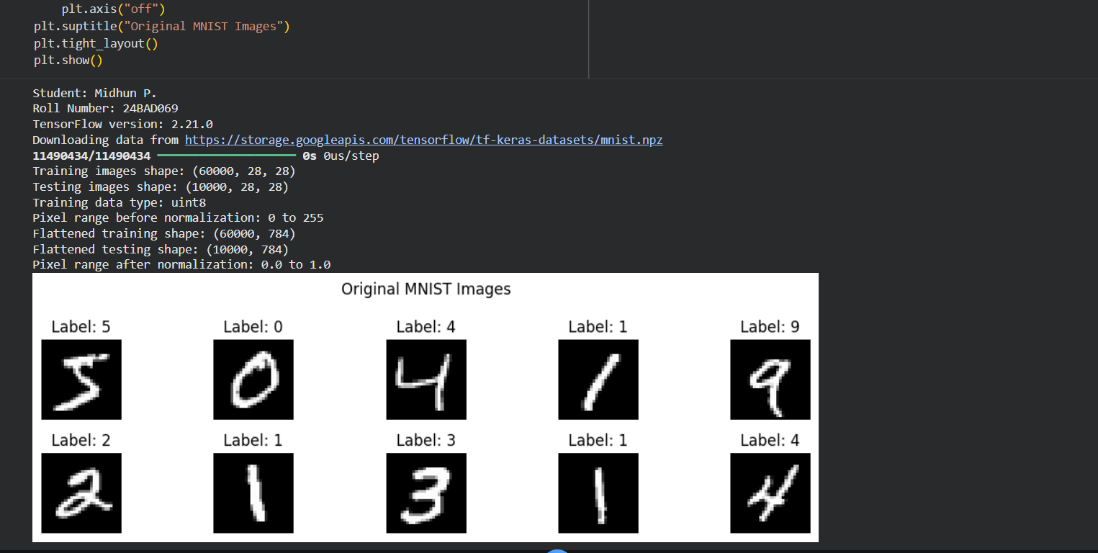

PART B: IMPLEMENTING THE AUTOENCODER MODEL
Perform the following tasks:
- Define the input layer based on the dimensions of the dataset.
- Create an Encoder using one or more Dense layers.
- Introduce a bottleneck layer with fewer neurons than the input layer to learn a compact representation.
- Create a Decoder to reconstruct the input from the bottleneck representation.
- Use a suitable activation function, such as ReLU for hidden layers and Sigmoid for normalized image reconstruction.
- Combine the Encoder and Decoder to construct the complete Autoencoder.
- Compile the model using an appropriate optimizer, such as Adam, and a reconstruction loss function, such as Mean Squared Error (MSE).
- Display the model architecture and model summary.

(CODE: CONATAINS STUDENT ROLL NOS
SCREENSHOT OF CODE
SCREENSHOT OF OUTPUT)

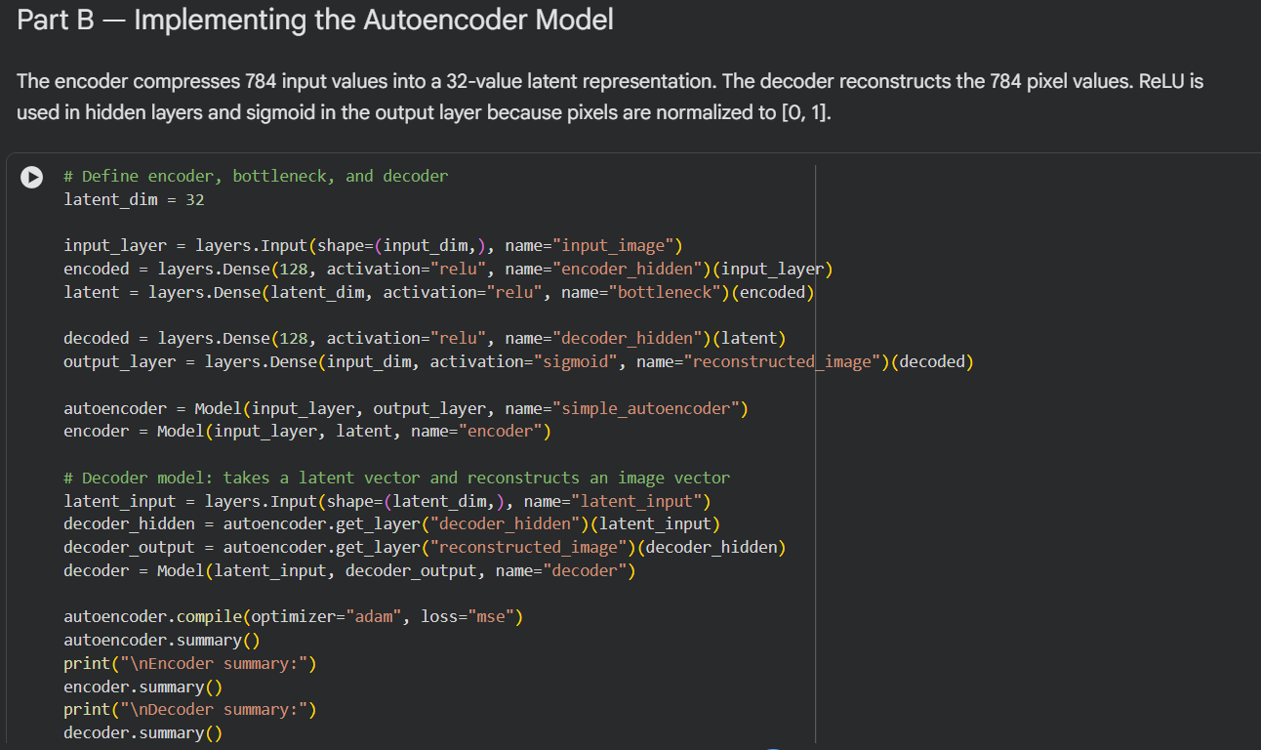
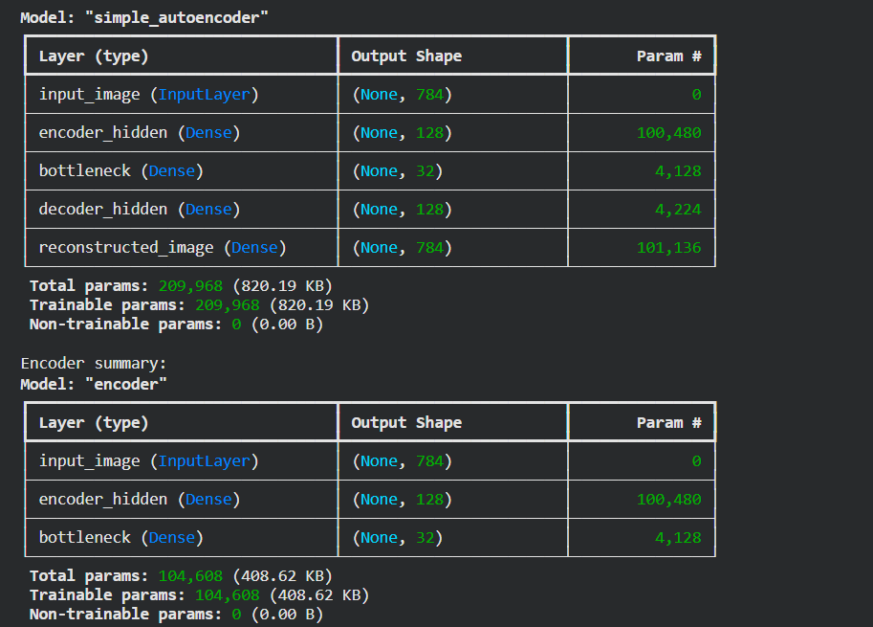
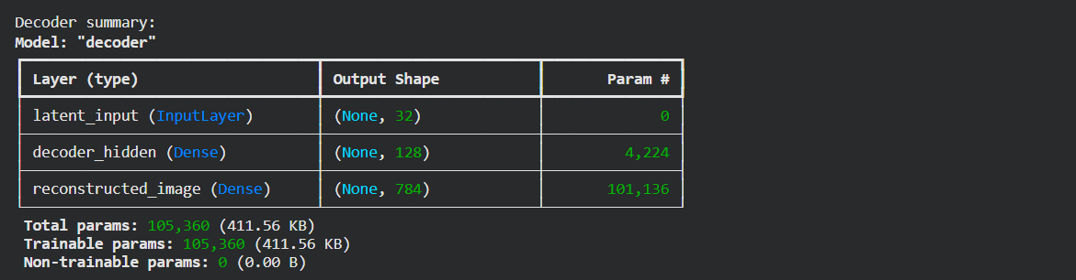

PART C: MODEL TRAINING AND PERFORMANCE EVALUATION
Perform the following tasks:
- Train the Autoencoder using the prepared training dataset.
- Use the original input samples as target outputs.
- Validate the model using validation data or the testing dataset, as appropriate.
- Record:
  - Training loss
  - Validation loss
- Evaluate the trained model using the test dataset.
- Calculate the reconstruction Mean Squared Error (MSE).
- Plot the training and validation loss against the number of epochs.
- Compare the original input images with their reconstructed outputs.

(CODE: CONATAINS STUDENT ROLL NOS
SCREENSHOT OF CODE
SCREENSHOT OF OUTPUT)

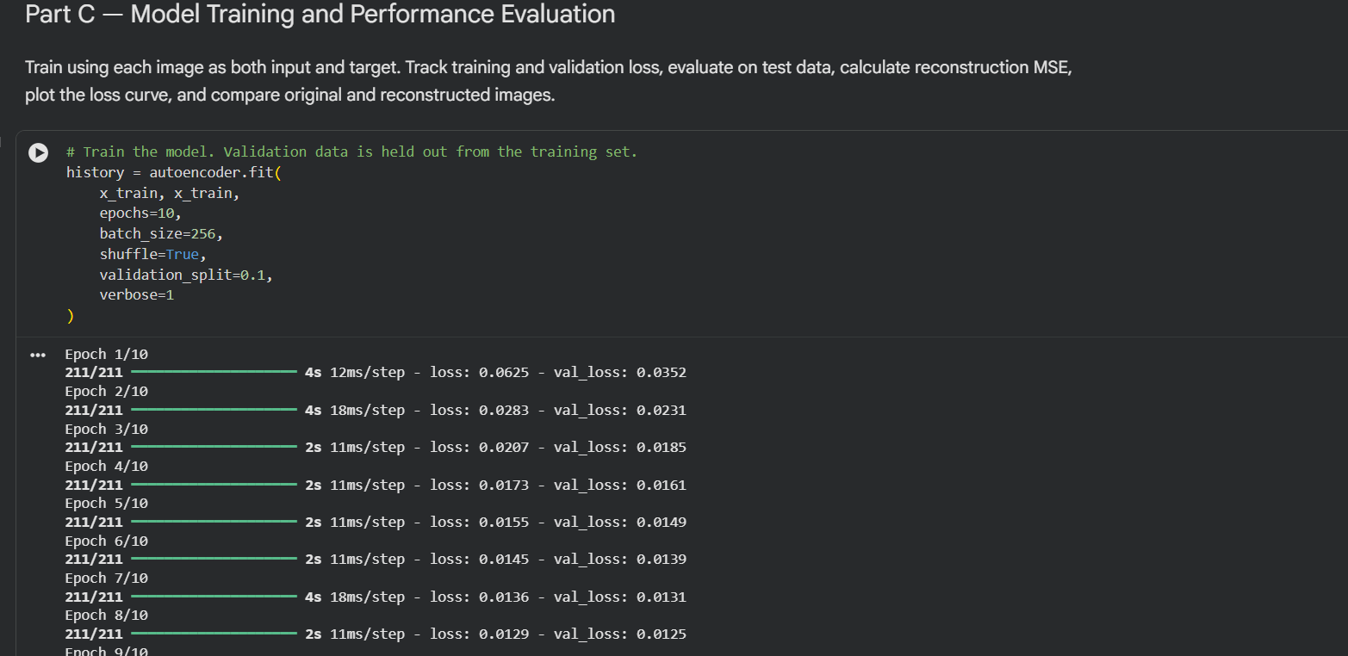
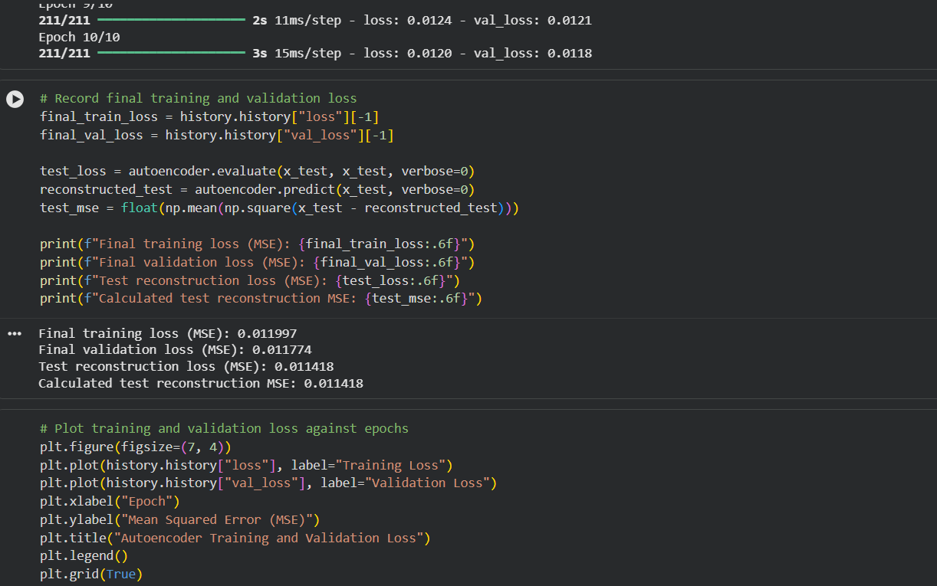
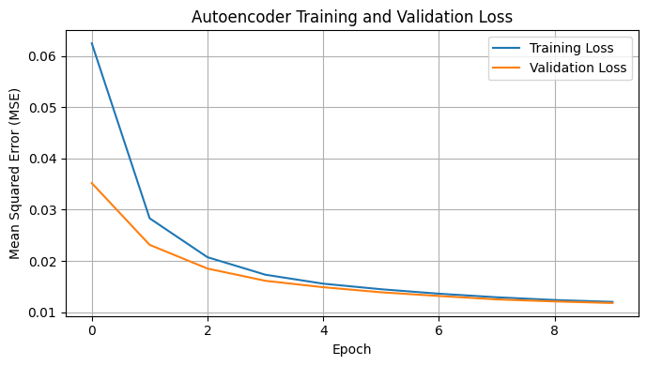
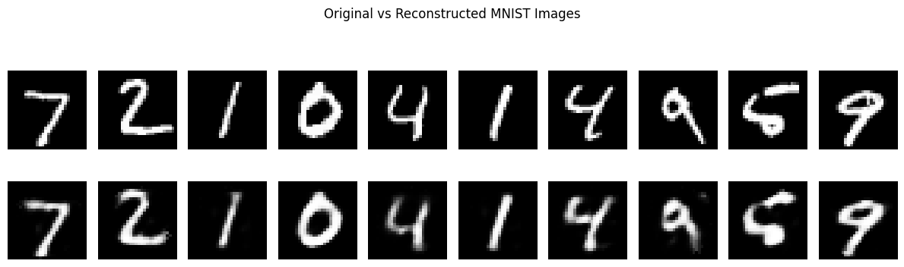

PART D: DIMENSIONALITY REDUCTION, FEATURE VISUALIZATION AND EXPERIMENT MANAGEMENT

Perform the following tasks:
- Provide new movie-review sentences as input to the trained LSTM model.
- Extract latent-space representations of test samples using the trained Encoder.
- Compare the dimensions of the original input data and compressed representations.
- Visualize the latent representations using a suitable plot.
- Reconstruct selected test samples using the Decoder and compare them with the original images.
- Record observations on dimensionality reduction and reconstruction quality.
- Document the observations and upload the notebook to GitHub.

(CODE: CONATAINS STUDENT ROLL NOS
SCREENSHOT OF CODE
SCREENSHOT OF OUTPUT)

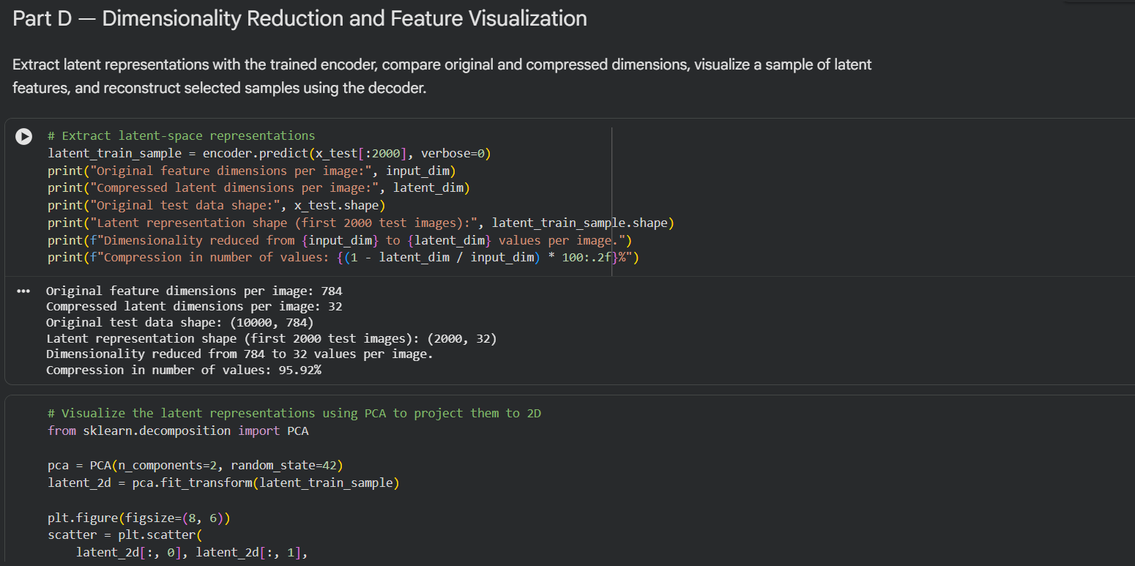
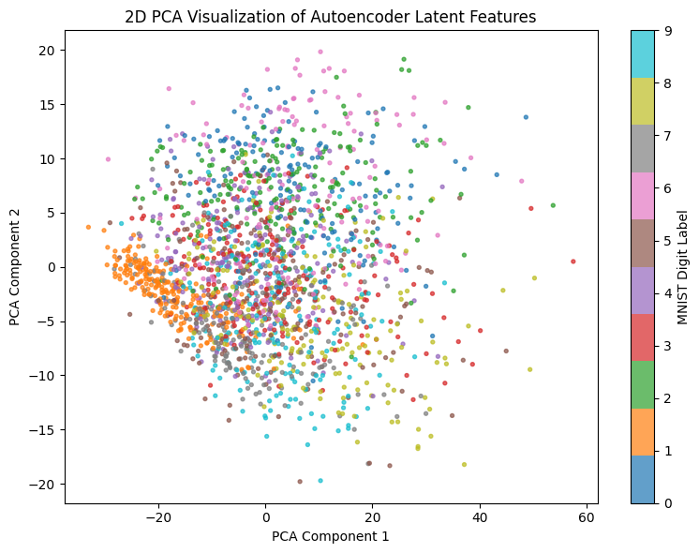

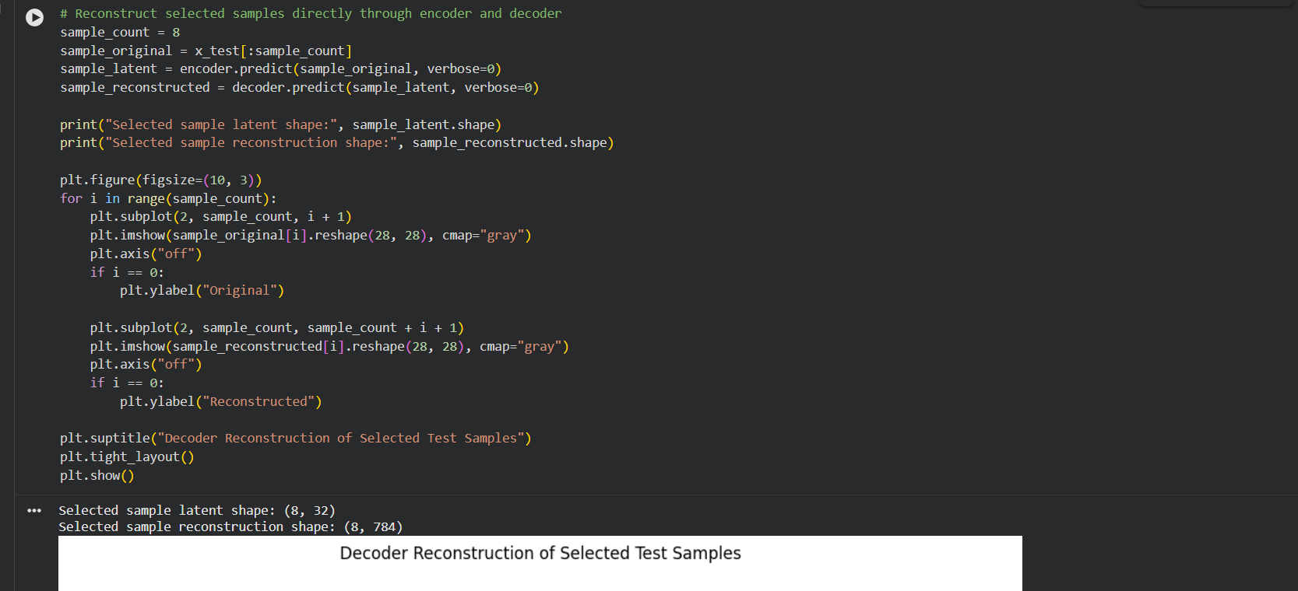
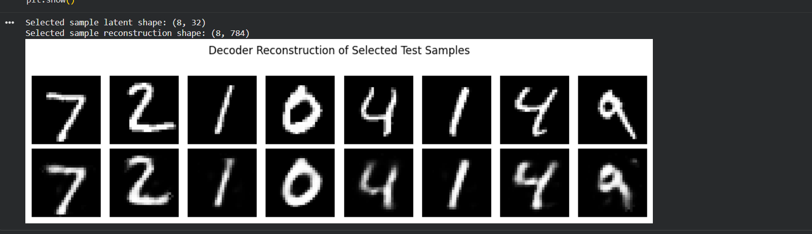

POST-LAB QUESTIONS (PROVIDE BRIEF ANSWERS TO THE FOLLOWING QUESTIONS)

- Explain the significance of reconstruction loss in training an Autoencoder.

Reconstruction Loss measures the difference between the original input and the output reconstructed by an Autoencoder.
It is the main objective used to train the network and improve reconstruction accuracy.
The Encoder first converts the input into a compressed latent representation.
The Decoder then reconstructs the original input from this compressed representation.
The reconstructed output is compared with the original input using a loss function.
A common loss function is Mean Squared Error (MSE), which calculates the average squared difference between actual and reconstructed values.
During backpropagation, the network updates its weights to minimize this loss.
A lower reconstruction loss indicates that the reconstructed output is closer to the original input.
Thus, reconstruction loss helps the Autoencoder learn meaningful latent features and produce accurate reconstructions.

- State one advantage of Autoencoders over traditional dimensionality-reduction techniques.

Autoencoders have an advantage over traditional dimensionality reduction methods because they can learn complex nonlinear relationships in data.
Unlike PCA, which mainly captures linear patterns, Autoencoders use neural networks and activation functions to learn more complex features.
This makes them effective for handling high-dimensional data such as images, audio, and text.
For example, handwritten digit images contain curves and shapes that are difficult to represent using only linear relationships.
Autoencoders can learn meaningful nonlinear features from such patterns.
Their architecture is flexible, allowing the number of layers and neurons to be adjusted for different tasks.
They learn representations directly from training data by minimizing reconstruction loss.
This enables the model to capture important information while reducing dimensionality.
Thus, Autoencoders are powerful tools for dimensionality reduction when data contains complex nonlinear patterns.

- Discuss two practical applications of Autoencoders apart from dimensionality reduction.

Autoencoders have applications beyond dimensionality reduction, including anomaly detection and image denoising.
In anomaly detection, the model is trained on normal data so it can reconstruct normal inputs accurately.
When unusual data is provided, the reconstruction error becomes higher, indicating a possible anomaly.
This approach is used in fraud detection, fault diagnosis, and network security monitoring.
In image denoising, the Autoencoder learns to reconstruct clean images from noisy inputs.
The model is trained by comparing reconstructed images with their original clean versions.
This helps remove unwanted noise while preserving important image features.
Image denoising is useful in digital photography, medical imaging, and image restoration.
Thus, Autoencoders are valuable for detecting anomalies and improving image quality through denoising.

ASSESSMENT
Description | Max Marks | Marks Awarded
Pre Lab Exercise | 5
In Lab Exercise | 10
Post Lab Exercise | 5
Viva | 10
Total | 30
Faculty Signature

